Dactylic Hexameter

📏 What is Dactylic Hexameter
# Source: Chatgpt (GPT-4-turbo) at [8/2/2025]
Dactylic Hexameter is a classical poetic meter made of:
- Six metrical feet per line
- Each foot is usually a dactyl: one stressed syllable followed by two unstressed syllables
→ DUM-da-da DUM-da-da DUM-da-da DUM-da-da DUM-da-da DUM-da-da
However, the last foot is often a spondee (two stressed syllables) or trochee (stressed–unstressed), making the line end slightly differently.

🧱 Structure
# Source: Chatgpt (GPT-4-turbo) at [8/2/2025]
- Meter: ( / ˘ ˘ ) × 5 + ( / ˘ ˘ or / / )
- Line ends in a dactyl or spondee
- Often uses caesura (a pause in the line) for variation

📝 Example (English Translation)
# Source: Chatgpt (GPT-4-turbo) at [8/2/2025]
Arms and the man I sing, who, forced by fate and the goddess…
— Opening of Virgil’s Aeneid
Original Latin:
Arma virumque canō, Trōiae quī prīmus ab ōris…

🔀 Variations
# Source: Chatgpt (GPT-4-turbo) at [8/2/2025]
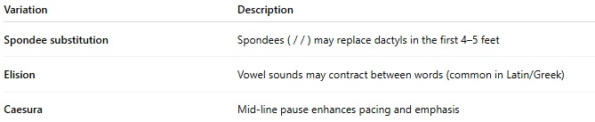
Variation | Description
Spondee substitution | Spondees ( / / ) may replace dactyls in the first 4–5 feet
Elision | Vowel sounds may contract between words (common in Latin/Greek)
Caesura | Mid-line pause enhances pacing and emphasis

🧬 Poetic Use & Effect
# Source: Chatgpt (GPT-4-turbo) at [8/2/2025]
- Evokes grandeur, formality, and epic tone
- Ideal for long narrative poetry, especially epics

🏛️ Where It’s Found
# Source: Chatgpt (GPT-4-turbo) at [8/2/2025]
- Ancient Greek and Roman epic poetry, including:
  - Homer’s Iliad and Odyssey
  - Virgil’s Aeneid
  - Ovid, Lucretius, and other classical poets
- Rare in English poetry due to the natural stress pattern of English, but used occasionally for classical imitation.

